**Programming Principles 02**

**Tutorials 05**

**Task 1 – Enhancing the “convert”**

**1.**

**convert.java**

public class Convert {

public static final double MM_IN_INCH = 25.4;

public static final double MM_IN_FOOT = 304.8;

public static final double MM_IN_YARD = 914.4;

public static final double MM_IN_MILE = 1609344;

public static double cm2inches(double cm) {

return cm * 0.393;

}

public static double m2feet(double m) {

return m * 3.281;

}

public static double m2yards(double m){

return m * 1.094;

}

public static double km2miles(double km ){

return km * 0.621;

}

}

**convertTest.java**

public class ConvertTest {

public static void main(String[] args) {

System.out.println("20 metres is "+ Convert.m2feet(20) + " feet.");

System.out.println("4 miles is " + Convert.MM_IN_MILE * 4 +" millimetres.");

}

}

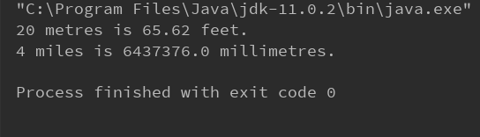

**2.**

**convert.java**